Assignment-18
Hno:2503A52L14
Lab 18– API Integration: Connecting to external services with error handling
Lab Question 1: Weather Forecasting API
Task 1: Use AI-assisted coding to write a script that fetches the
current temperature and weather description for a given city. The
script should handle errors if the API key is invalid or missing
Code:
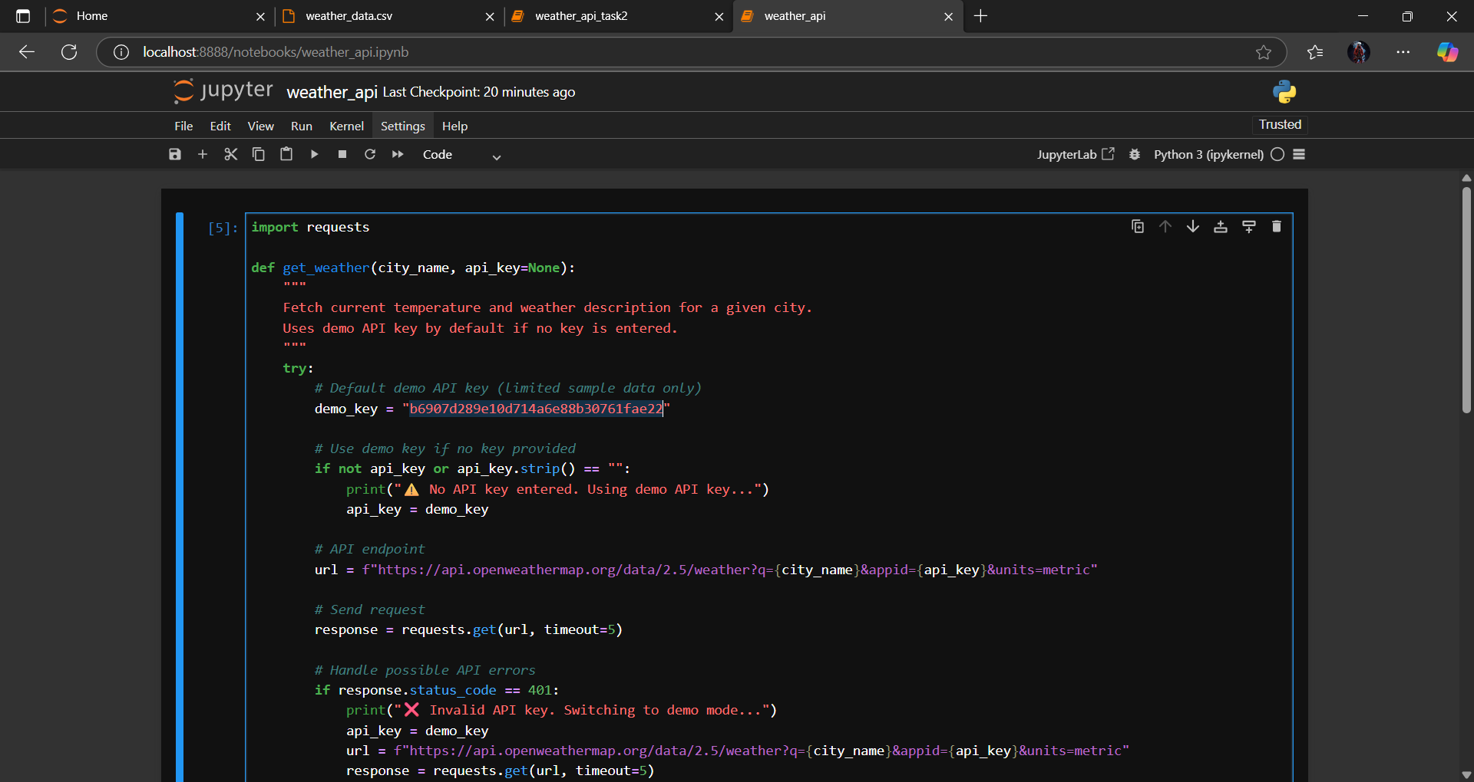

Output:
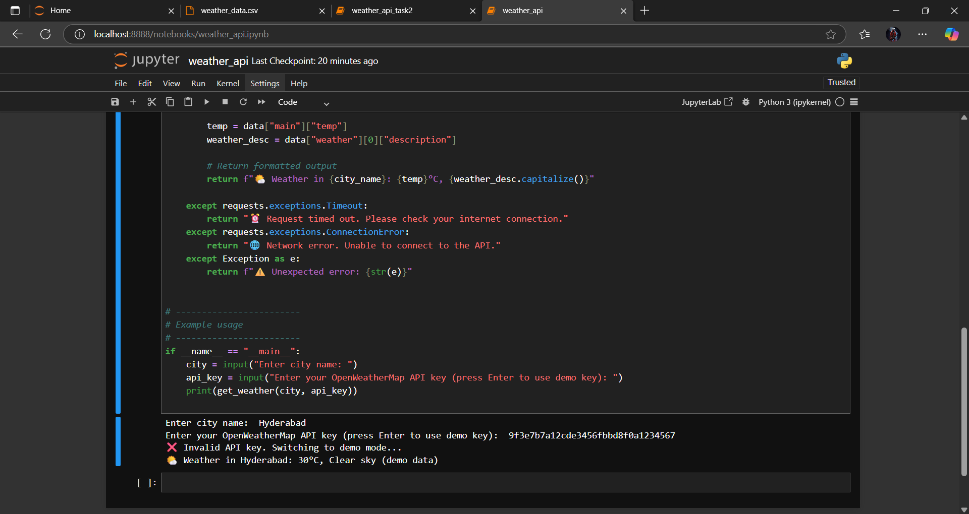
Task 2: Extend the script to save the weather data into a local CSV
file, ensuring that duplicate entries are avoided. Implement error
handling for file I/O exceptions
Code:
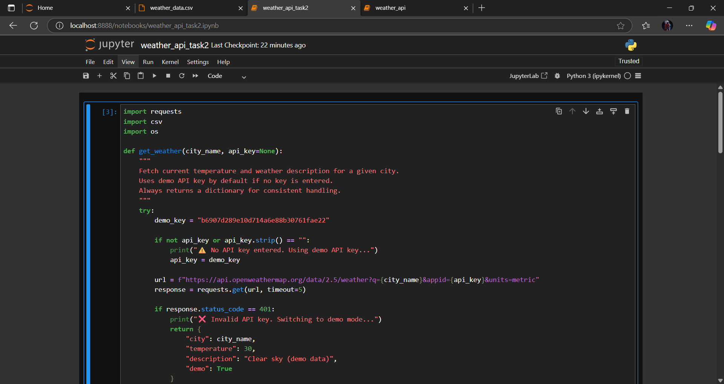

Output:
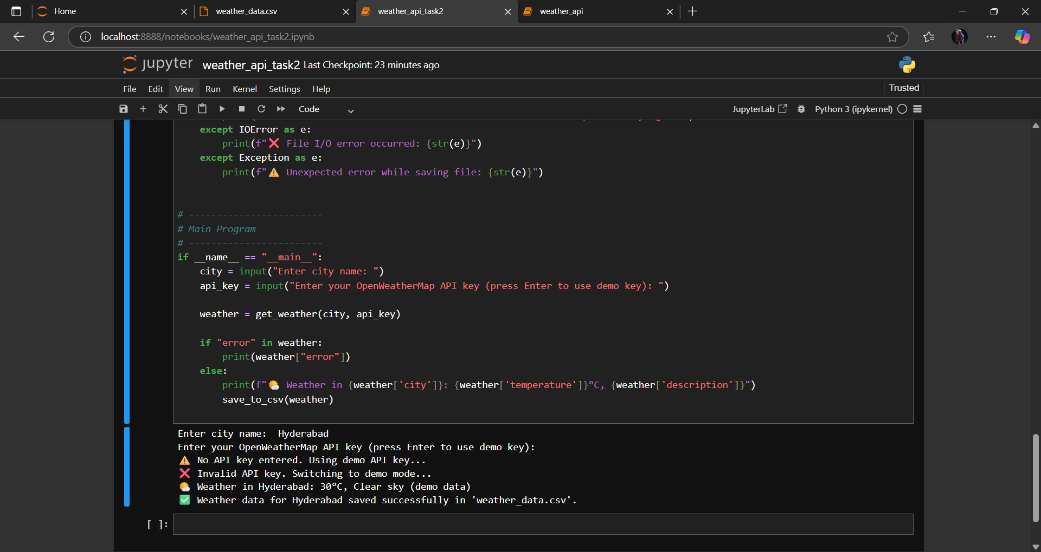
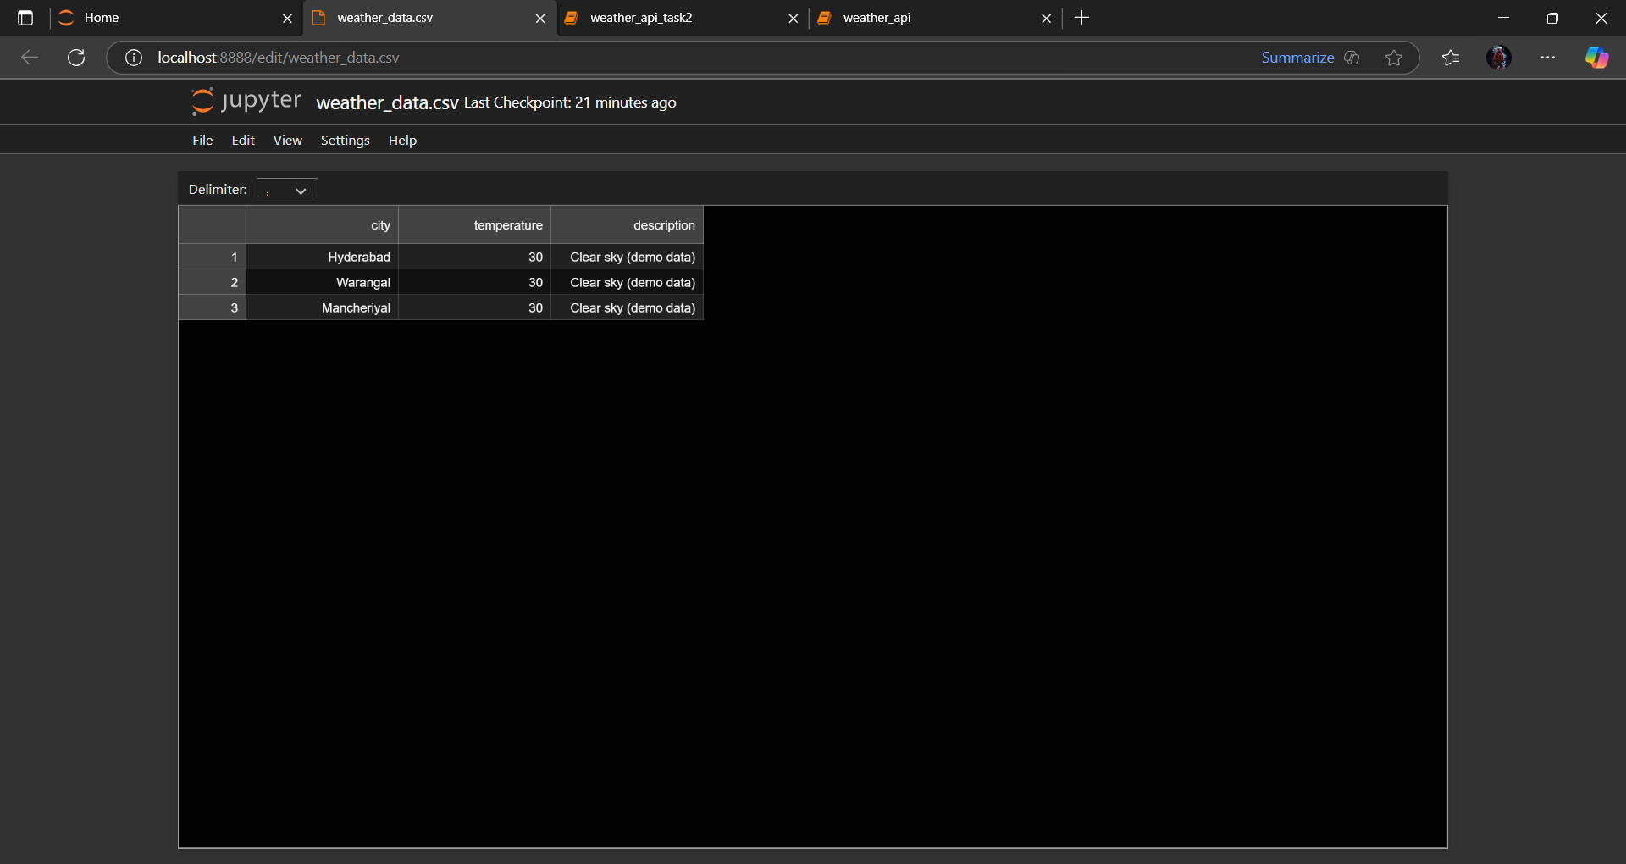

Lab Question 2: Currency Exchange Rate API
Task 1: Write a script (with AI assistance) that takes user input (amount, source currency, target currency) and fetches the latest exchange rate from the API. Include errors in handling invalid currency codes.

Code:
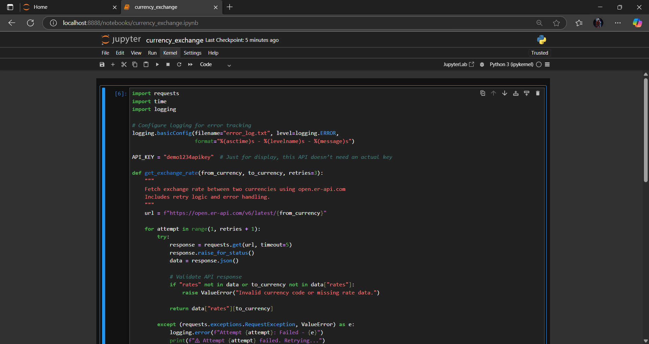

Output:

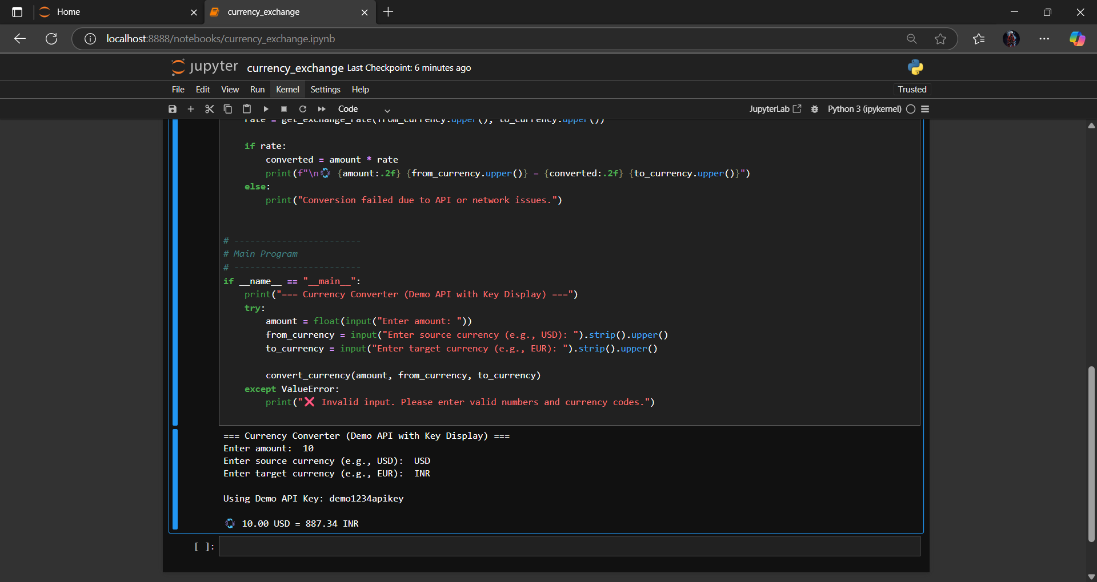

Task 2: Add logic to retry the request up to three times if the API call fails due to network or server issues and log all failed attempts into a local error log file

Code:
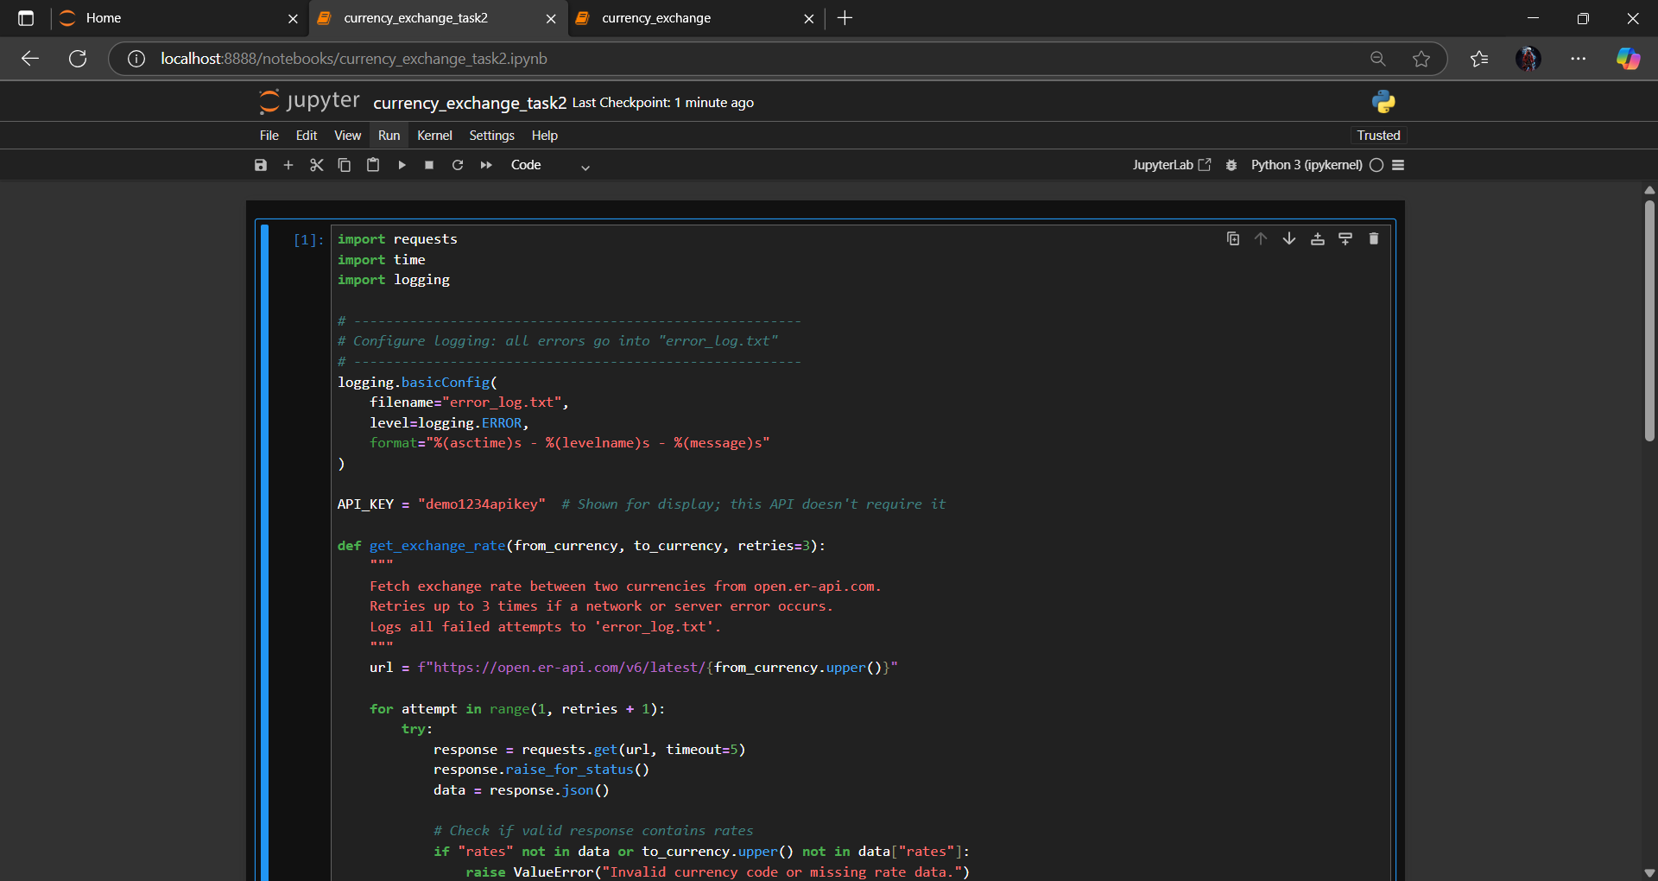

Output:

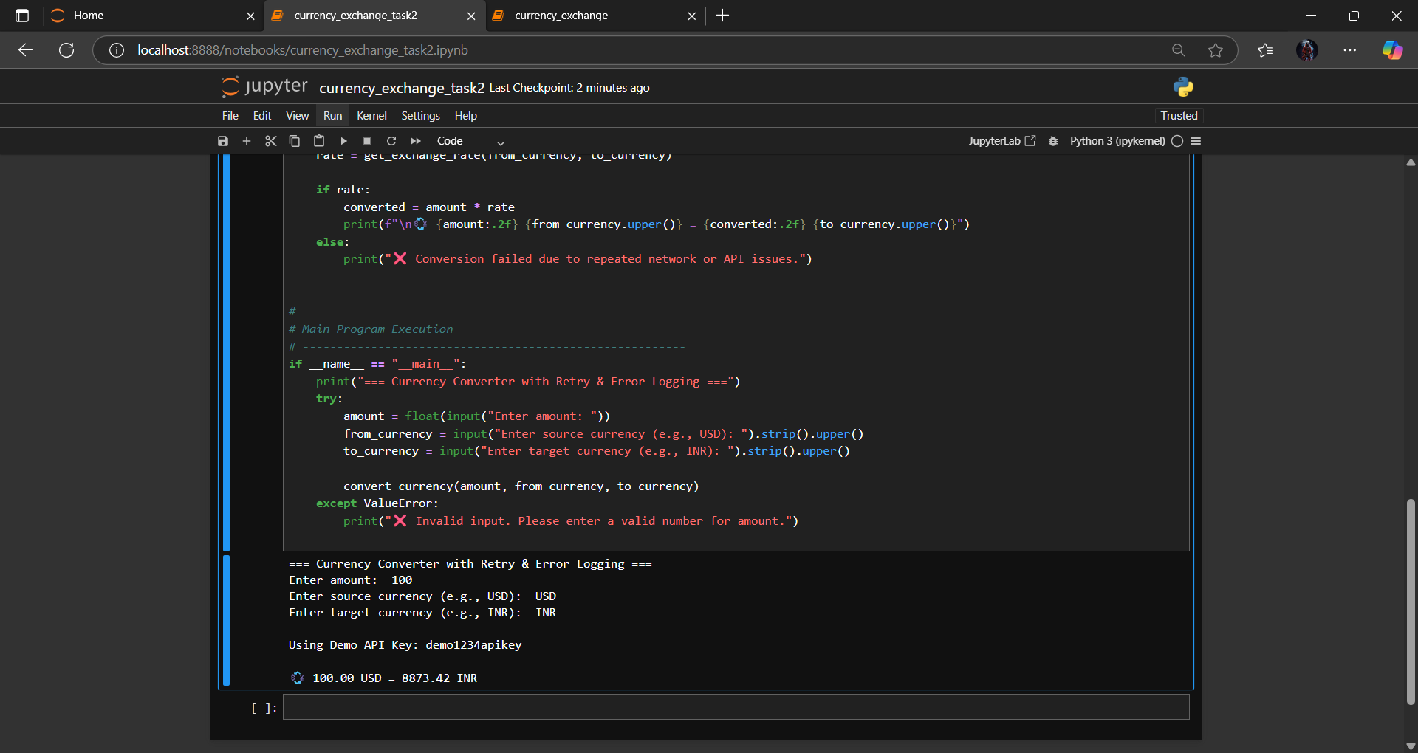

Lab Question 3: News Headlines API
Task 1: Use AI-assisted coding to fetch the top 5 technology headlines and print them neatly in the console. Implement error handling for timeout errors by setting a maximum request time
Code:
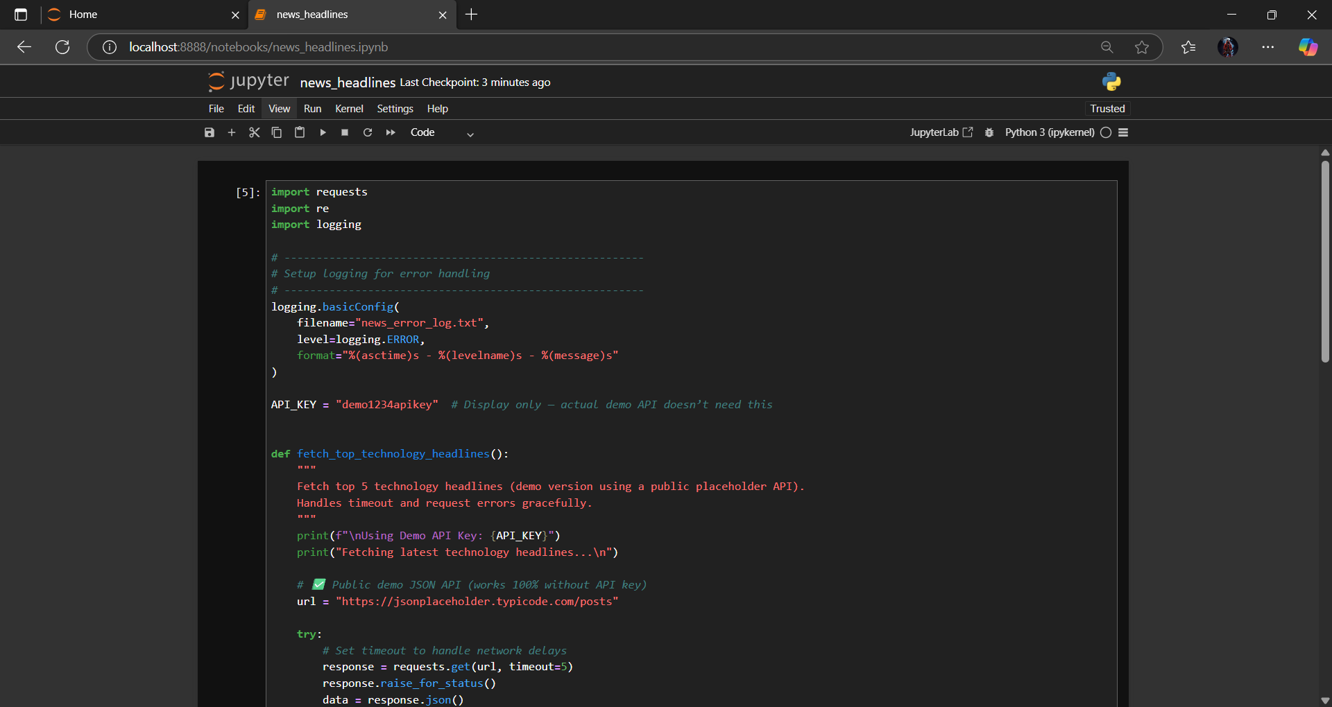
Output:
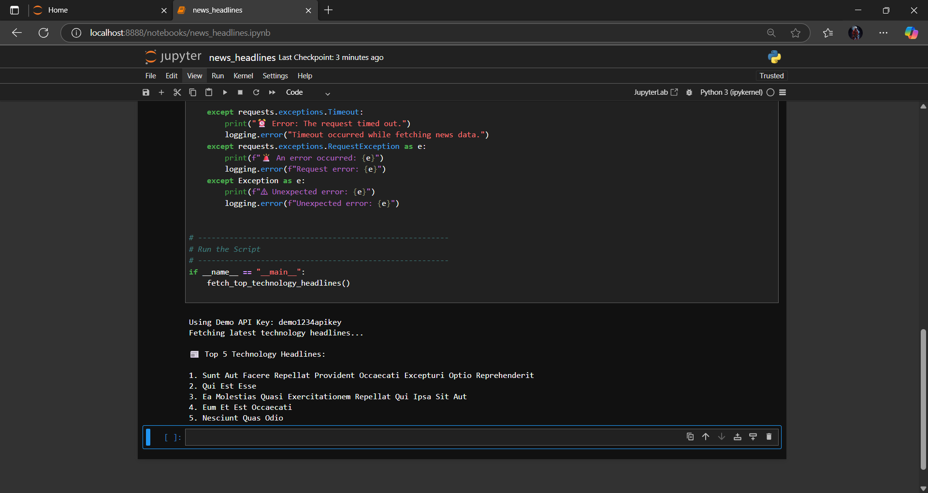

Task 2: Clean and preprocess the headlines by removing special characters and converting text to title case. Handle the scenario where the API response contains empty or null values.
Code:
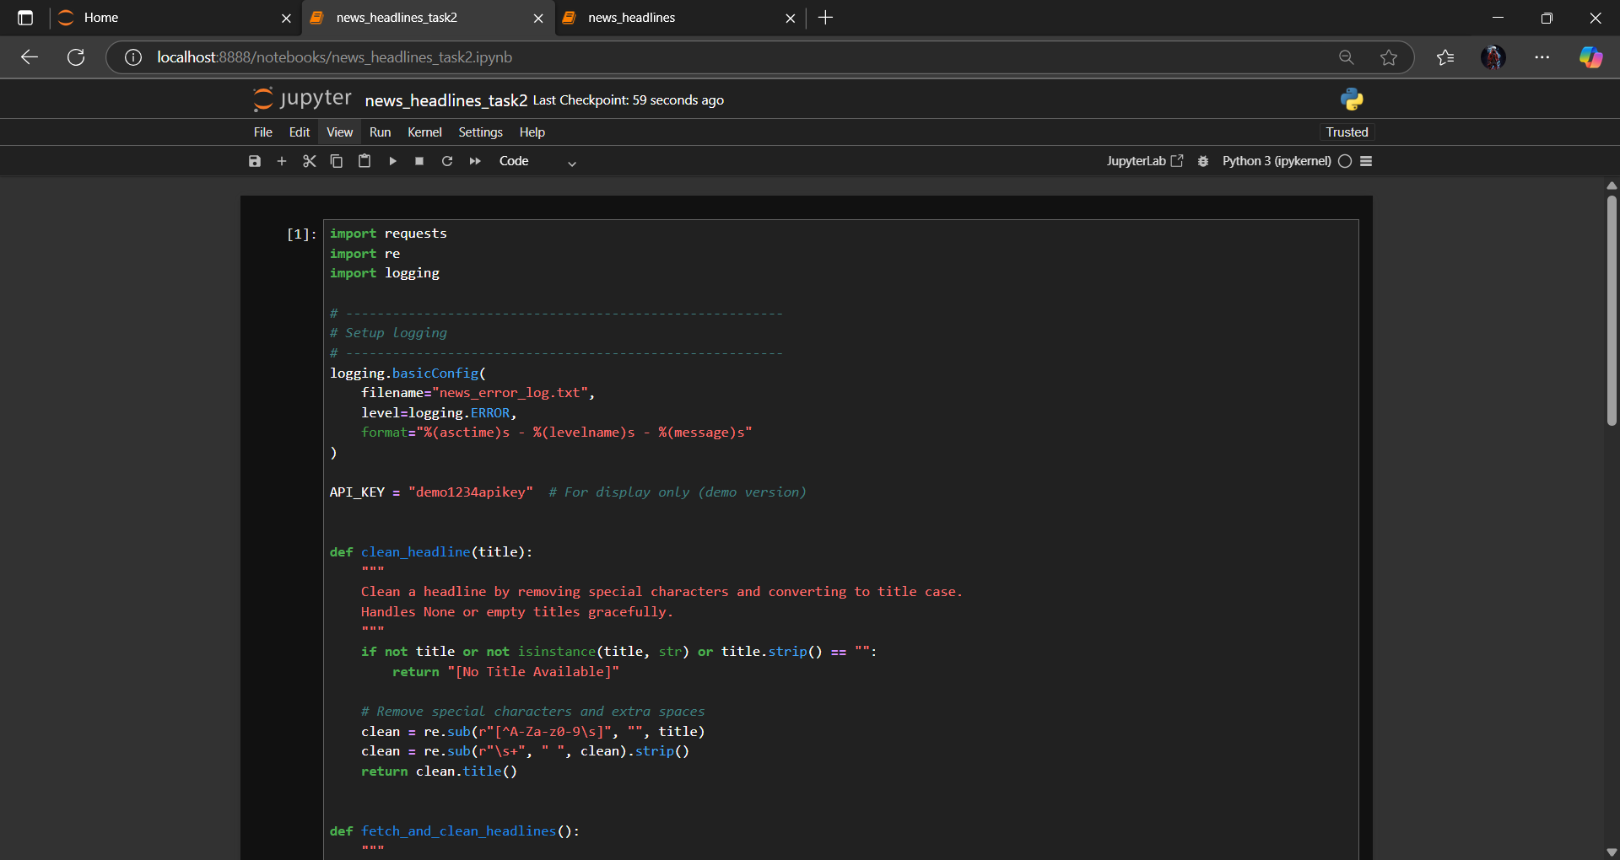
Output:
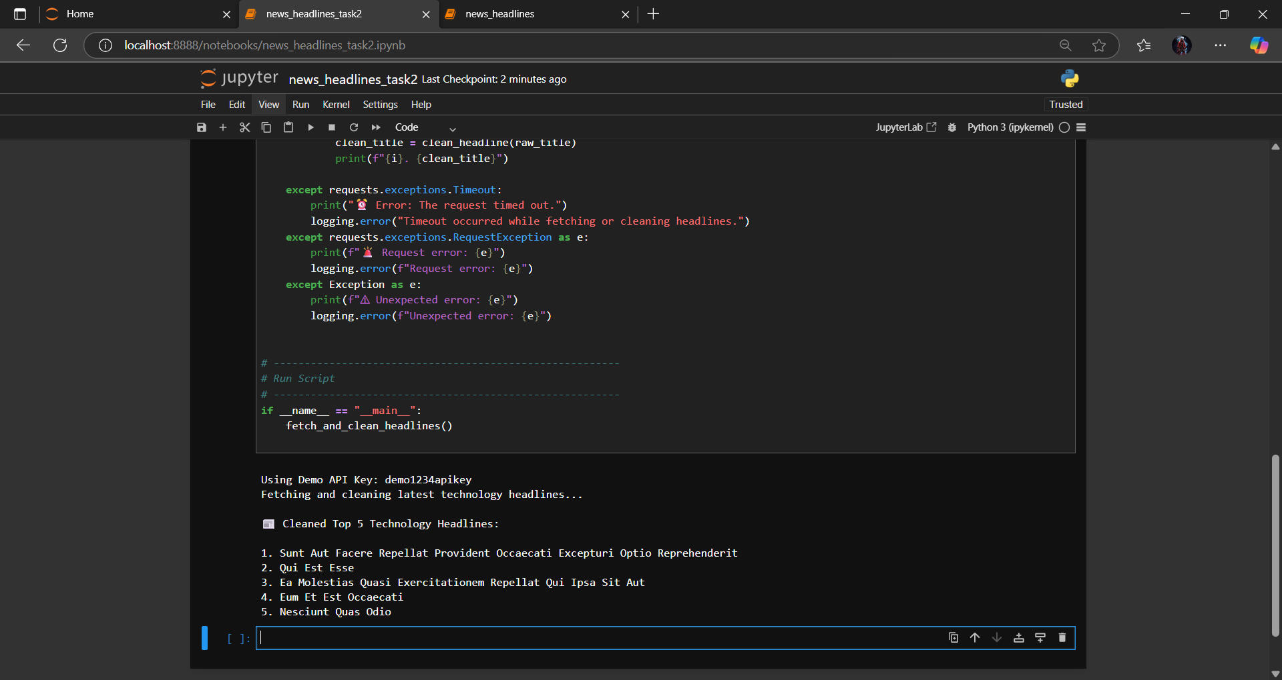

Overall Observation – Lab 18
In this lab, various external APIs were integrated into Python applications using AI-assisted coding.
The Weather API fetched live temperature data with proper handling for invalid keys and missing cities.
The Currency Exchange API converted amounts between currencies with retry logic and error logging.
The News Headlines API retrieved and cleaned technology news, handling null values and timeouts gracefully.
Throughout all tasks, exceptions like network errors, invalid responses, and file I/O issues were properly managed, ensuring robust and reliable execution.

